## Designing a Website with HTML and CSS

**Lab Time**: 45 minutes

**Lab Folder**: C:\Student\Labs\Lab03_Design

### Exercise 1: Implementing a Design with HTML and CSS

In this exercise you will create CSS rules to integrate a set of graphic images into an HTML layout to create a custom page design. Note that it will be helpful if you install **Microsoft Expression Web** before the start of this lab. If you do not install Microsoft Expression Web, you can still complete this lab with **NOTEPAD.EXE** but the design experience will not be as good. If you are familiar with Visual Studio 2010 and you have it installed, you can also use this development environment to complete the HTML editing work in this lab.

1. In the browser, locate the folder at the following path and examine what is inside:

C:\Student\Labs\Lab03_Design\Start

1. Inside the folder, you should find **default.html**, **styles.css** and an inner folder name **images**.

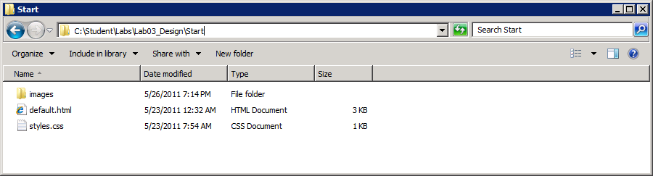

1. Examine the files inside the **images** folder. This folder contains the images you will be adding to an HTML page design by creating CSS rules.

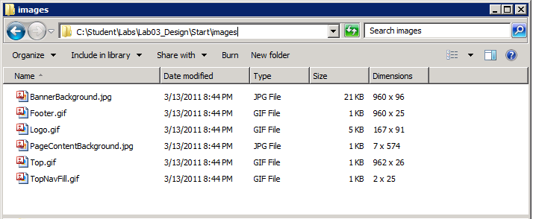

1. In the browser, double-click on **defaut.html** in the **Start** folder. This should display the starting page layout in the browser.

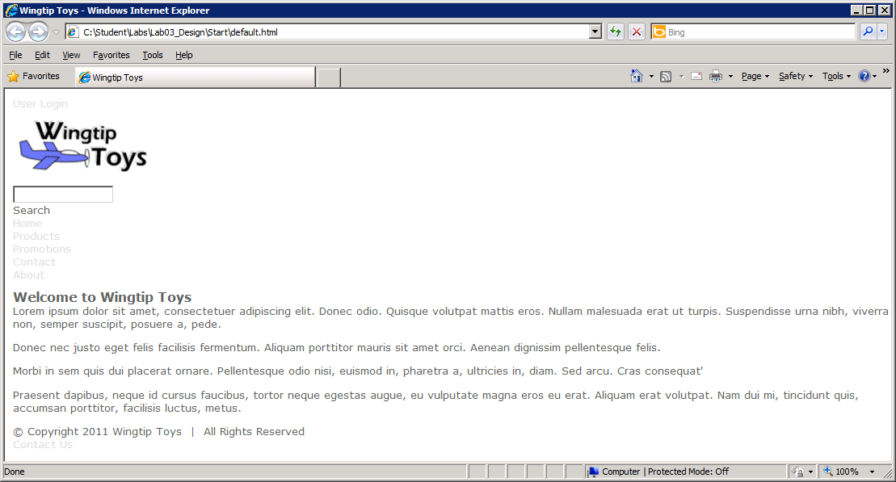

1. Now it is time to begin editing this page layout with Microsoft Expressions Web. Launch Microsoft Expressions Web from the following shortcut in the Windows Start menu:

Start > All Programs > Microsoft Expression > Microsoft Expression 4

1. Now it’s time to open the Website inside the Start directory. From within Microsoft Expression Web 4, drop down the **Site** menu and select the **Open Site…** menu command. Open the site located at the path **C:\Student\Labs\Lab03_Design\Start**.

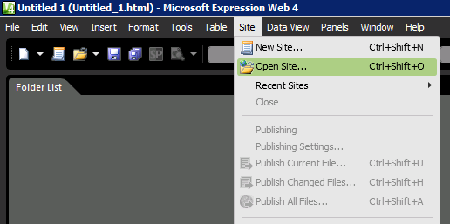

1. You should now be able to see default.htm and styles.css inside Microsoft Expressions Web.

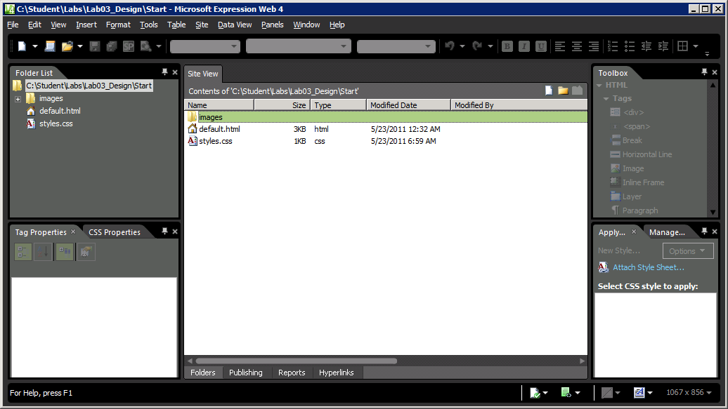

1. Inside Microsoft Expression Web, open **default.html** by double clicking on in. This should open this HTML file inside the page designer of Microsoft Expression Web. Experiment by examining the page in Design view, Code view and Split view. Take the time to go through the HTML so you can understand its high-level structure. Note that **default.html** already contains a link to **styles.css**.

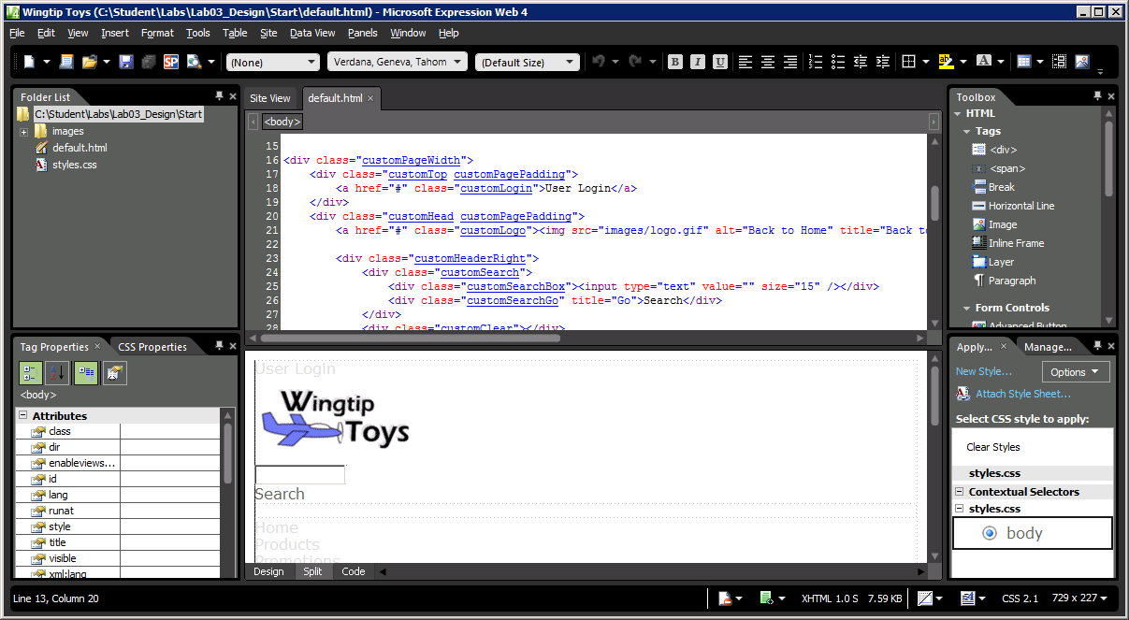

1. Open the CSS file named style.css by double-clicking on it. You should see that there are a few CSS rules defined at the top. At the bottom of styles.css, you should also see some comments in the section where you will add new CSS rules.
2. Locate the following comment in **styles.css**:

/* Add rules for page width here (snippet01.txt) */

1. Below this comment, add the following CSS rules. If you want to, you can copy the CSS rules from a file named **snippet01.txt** in the **Lab03_Design\Snippets folder**.

.customPageWidth {

width: 960px;

height: 100%;

margin: auto;

padding-top: 10px;

}

.customPagePadding {

padding: 0px 20px;

}

.customClear {

clear: both;

}

1. Save and test your work. Your page should now render with a centered page as shown below.

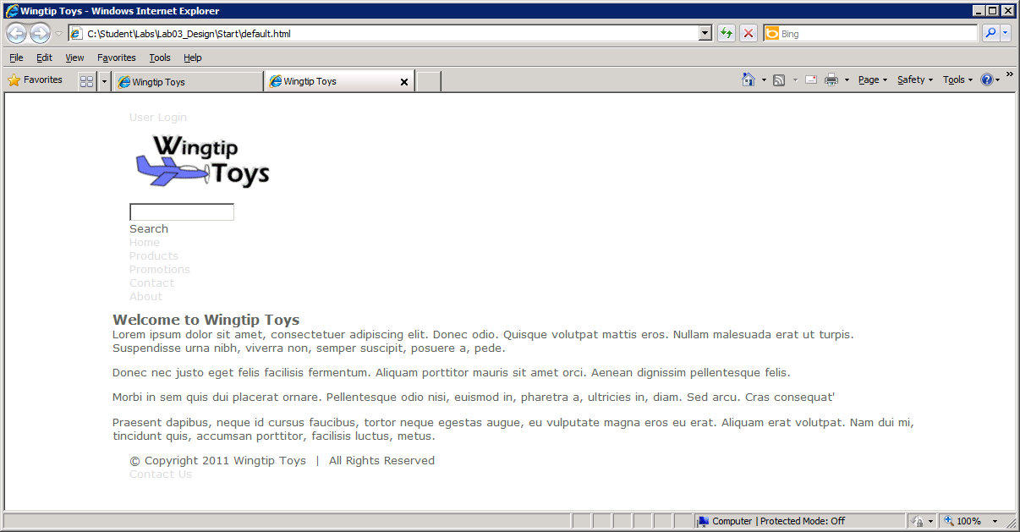

1. Locate the following comment in **styles.css**:

/* Add rules for top row here (snippet02.txt) */

1. Below this comment, add the following CSS rules. If you want to, you can copy the CSS rules from a file named **snippet02.txt** in the **Lab03_Design\Snippets folder**.

.customTop {

background-image: url('images/Top.gif');

background-color: transparent;

background-repeat: no-repeat;

height: 24px;

width: auto;

}

.customTop a {

color: white;

font-size: 8pt;

font-weight: bold;

}

.customLogin {

background-image: none;

background-repeat: no-repeat;

float: right;

height: 10px;

position: relative;

top: 5px;

}

1. Save and test your work. Your page should now render with a top row as shown below.

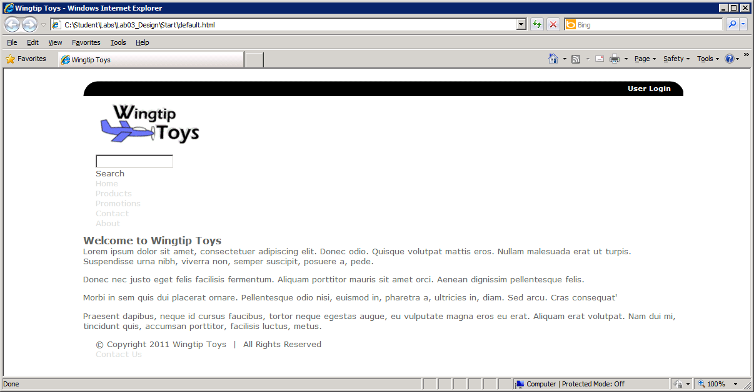

1. Locate the following comment in **styles.css**.

/* Add rules for banner row here (snippet03.txt) */

1. Below this comment, add the following CSS rules. If you want to, you can copy the CSS rules from a file named **snippet03.txt** in the **Lab03_Design\Snippets folder**.

.customHead {

background-image: url('images/BannerBackground.jpg');

background-color: #FFFFFF;

background-repeat: no-repeat;

height: 96px;

width: auto;

}

.customHeaderRight {

float: right;

}

.customSearch {

float:right;

position:relative;

top:20px;

}

.customSearchBox {

background-image: none;

background-repeat: no-repeat;

height: 20px;

width: 180px;

float: left;

}

.customSearch input {

background-color:white;

border:0 none;

font-size:93%;

padding:4px 0 0 4px;

width:95%;

}

.customSearchGo {

float: left;

background-image: none;

background-repeat: no-repeat;

height: 20px;

width: 62px;

float: left;

}

1. Save and test your work. Your page should now render with a banner as shown below.

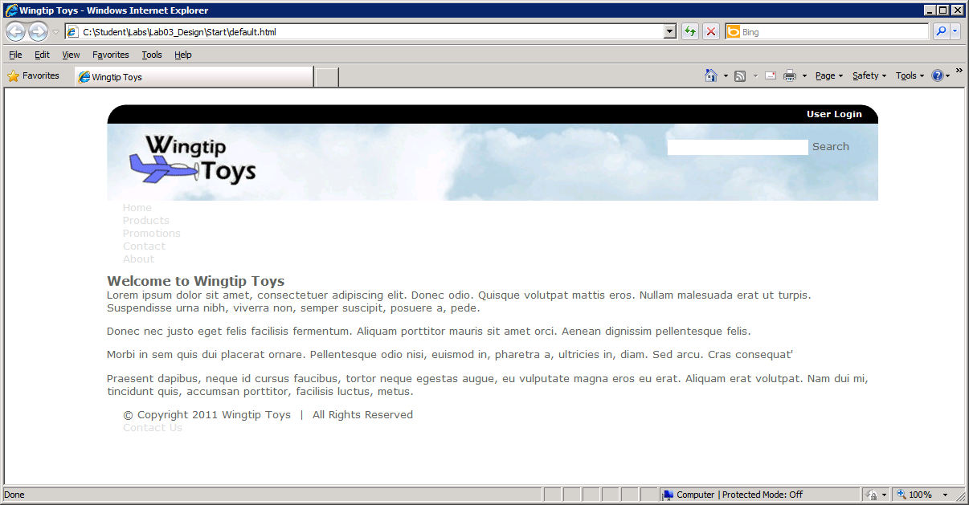

1. Locate the following comment in **styles.css**.

/* Add rules for global navigation row here (snippet04.txt) */

1. Below this comment, add the following CSS rules. If you want to, you can copy the CSS rules from a file named **snippet04.txt** in the **Lab03_Design\Snippets folder**.

.customNav {

background-image: url('images/TopNavFill.gif');

background-repeat: repeat-x;

background-color: black;

height: 24px;

border-color: black;

border-style: solid;

border-width: 0px;

border-collapse: collapse;

}

.customTopNavHolder {

float: left;

}

.customTopNavItem {

float:left;

font-size: 10pt;

height:17px;

padding: 4px 16px 0px 0px;

border-style: none;

}

.customTopNavItem a {

color: #FFFFFF;

font-size: 10pt;

font-weight: bold;

}

.customTopNavItem a:hover {

text-decoration:none;

}

.customTopNavItem:hover a {

color: yellow;

}

1. Save and test your work. Your page should now render with global navigation as shown below.

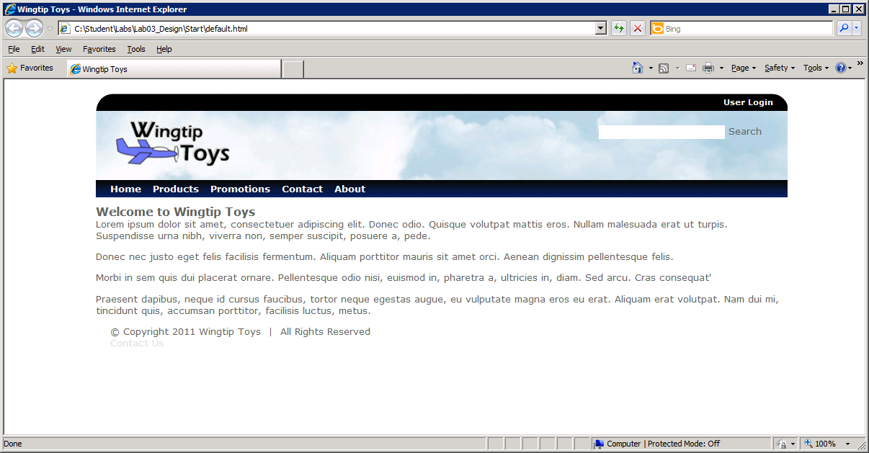

1. Locate the following comment in **styles.css**.

/* Add rules for footer row here (snippet05.txt) */

1. Below this comment, add the following CSS rules. If you want to, you can copy the CSS rules from a file named **snippet05.txt** in the **Lab03_Design\Snippets folder**.

.customFooter {

background-image: url('images/Footer.gif');

background-color: transparent;

background-repeat: no-repeat;

color: white;

font-size: 7pt;

height:27px;

padding-top: 6px;

}

.customFooter a {

color: white;

}

.customFooterLeft {

float: left;

}

.customFooterRight {

float: right;

padding-right:0px;

}

1. Save and test your work. Your page should now render with a footer as shown below.

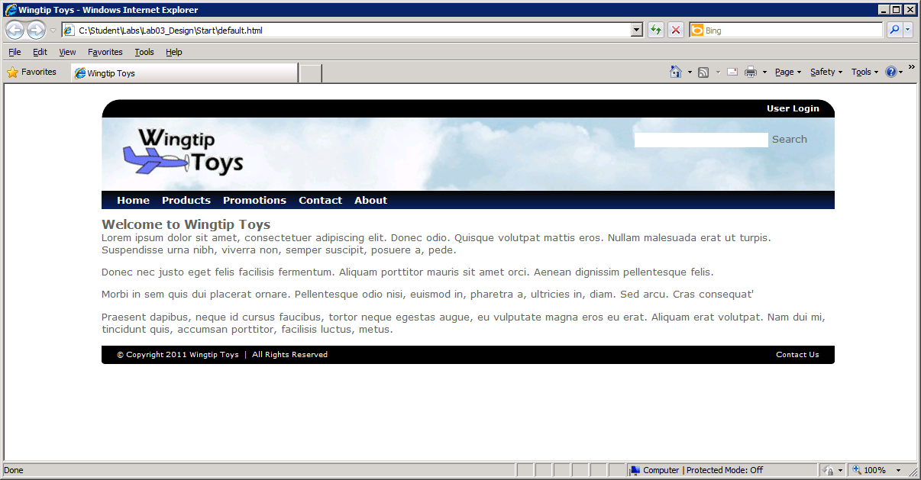

1. Locate the following comment in **styles.css**:

/* Add rules for body content row here (snippet06.txt) */

1. Below this comment, add the following CSS rules. If you want to, you can copy the CSS rules from a file named **snippet06.txt** in the **Lab03_Design\Snippets folder**.

.customBody {

background-image: url('images/PageContentBackground.jpg');

background-color:#FFFFFF;

background-repeat: repeat-x;

min-height: 420px;

overflow:auto;

border-color:#bbbbbb;

border-style:solid;

border-width:0 1px;

padding: 20px 8px 20px 8px;

width: 942px !important;

}

.customBody h1 {

font-size: 14pt;

font-weight:normal;

margin:2px 0 10px;

}

.customBody p {

font-size: 10pt;

font-weight:normal;

margin:2px 0 10px;

}

.customBodyImage {

padding-left: 4px;

}

1. Save and test your work. Your page should now render with a formatted body as shown below.

